**Project Name**

**Hangman**

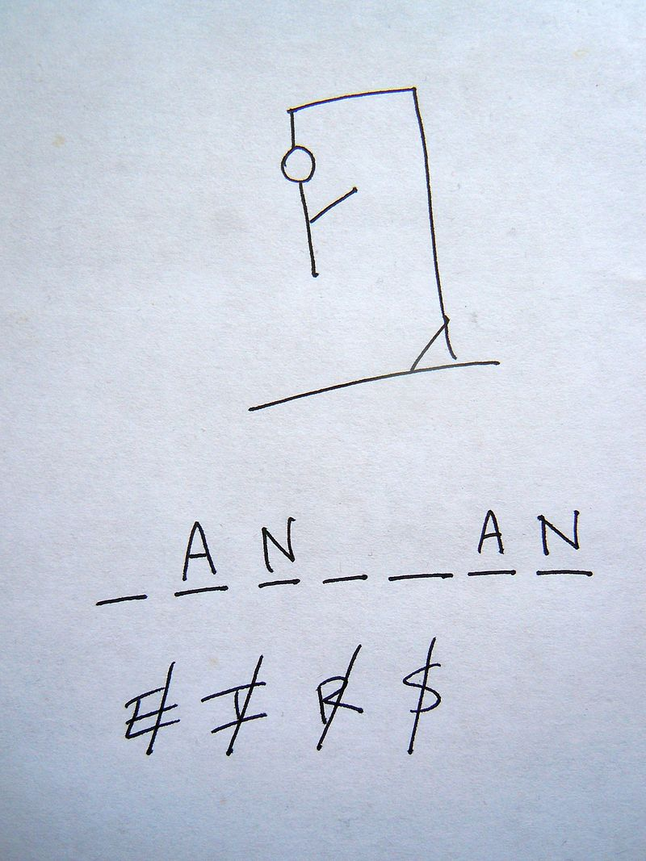

**Source:** [**https://en.wikipedia.org/wiki/Hangman_(game)**](https://en.wikipedia.org/wiki/Hangman_(game))

**Problem Statement:** Hangman is a [paper and pencil](https://en.wikipedia.org/wiki/Paper-and-pencil_game) [guessing game](https://en.wikipedia.org/wiki/Guessing#Guessing_games) for two or more players. One player thinks of a [word](https://en.wikipedia.org/wiki/Word), [phrase](https://en.wikipedia.org/wiki/Phrase) or [sentence](https://en.wikipedia.org/wiki/Sentence_(linguistics)) and the other(s) tries to guess it by suggesting [letters](https://en.wikipedia.org/wiki/Letter_(alphabet)) within a certain number of guesses. In this given project we created a list in which consists of all the popular Hollywood actors and our task is to guess that actor name letter by letter, where we have only 6 chances.So our task is to create this game with help of simple python programming with help of Loops, List etc. etc.

**Implementation**

**Workflow:**

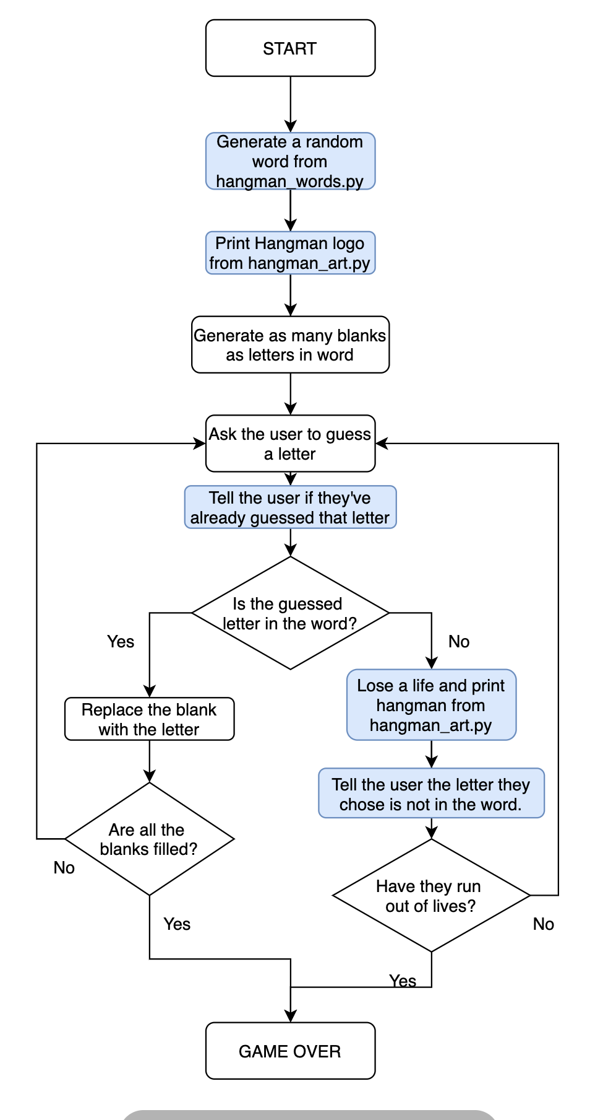

**Final Output will look something like this**

